Call for contributions

Dear Colleagues,

The EMPAQT project team invites you to promote your project, research, policy or practice at the

International Conference
Policies and practices for the prevention of Early School Leaving
The conference will take place from 2 till 4 May 2018 in Marma Hotel, Istanbul.

The conference topics are:
- European policies for tackling ESL
- Communication as a tool for prevention ESL
- Best practices in education of disadvantaged groups
- Social and Emotional learning
- School councillors - roles and challenges
- Teachers’ qualification for inclusive education
- Raising students’ engagement for education
- Multi-systemic (Multi-partner) approach for tackling ESL

The conference invites teachers, researchers, PhD students, psychologists, school counsellors and pedagogy experts, policy and decision makers in education, representatives of the Ministries of education, local authorities and other stakeholders to present and exchange ideas about pedagogical tools and other solutions for tackling Early School Leaving.
The official languages of the conference are English and Turkish. Simultaneous translation will be provided at the plenary sessions.
A dissemination area for materials and outcomes from implemented projects and initiatives, and an option for poster session will be available.
The conference participants will receive certificate for participation.

The conference host is:

Research and Application Centre for Street Children (SOYAÇ) at Maltepe University.
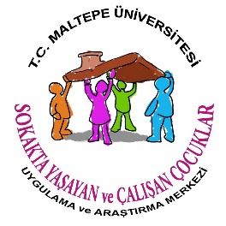
SOYAÇ is established in 2010 with the principal aim to develop research and application projects to assist in the rehabilitation of street children and children at risk. It is the first and the only center of its kind in Turkey, operating within a university context. The Center’s projects are carried out with active involvement of undergraduate and postgraduate university students from different departments (from psychology to fine arts) who work with socially excluded disadvantaged people.

The conference co-organisers are:
- Trakia University, Bulgaria
- Center for Creative Training Association, Bulgaria
- Institute of Education Sciences, Romania
- AFP Patronato San Vincenzo, Italy
- Muğla İl Milli Eğitim Müdürlüğü, Turkey
- Maltepe University, Research and Application Centre for Street Children, Turkey
- University of Malta, Centre for Resilience and Socio-Emotional Health, Malta
- Regional Department of Education-Silistra, Bulgaria

Conference venue

Marma Hotel
Büyükbakkalköy Mahallesi,
Maltepe Üniversitesi,
Marmara Eğitim Köyü No:34857,
Maltepe - İSTANBUL

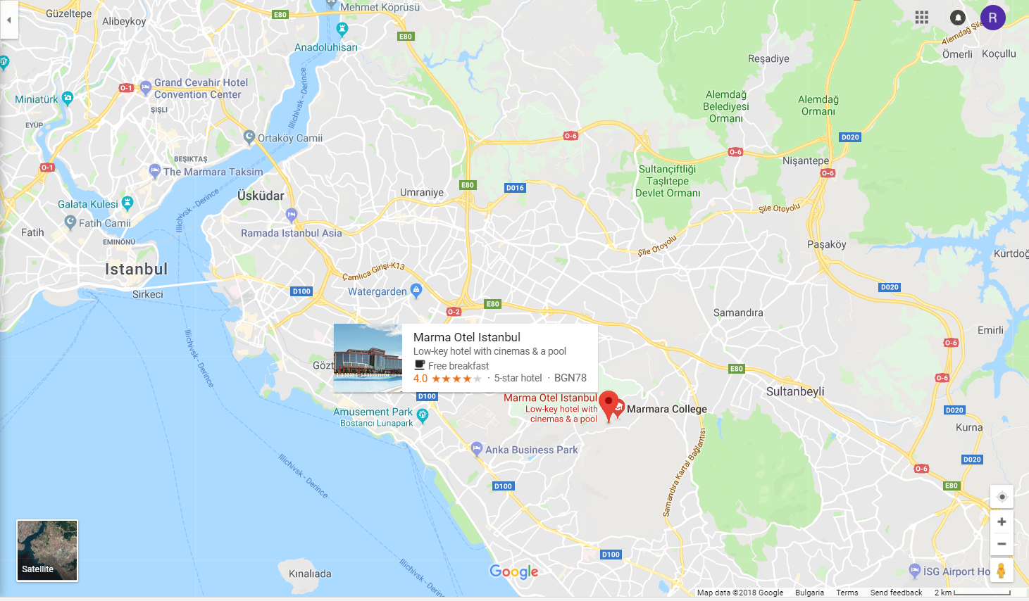

Conference costs

The participation in the conference is free of charge.

Costs for accommodation and food at the conference venue Marma Hotel, Istanbul are as follows:

Full Conference pack (2–4 May 2018)  - Opening ceremony and cocktail dinner (2nd May)  - 3 nights accommodation & full board (3 breakfasts, 3 lunches & 2 dinners)  - Conference materials and coffee-breaks | Single room  280 EUR | Double room  395 EUR
Basic Conference pack (3rd and 4th May 2018)  - 2 nights accommodation & full board (2 breakfasts, 2 lunches & 2 dinners / not including the opening ceremony)  - Conference materials and coffee-breaks | Single room  150 EUR | Double room  190 EUR
Premium Basic Conference pack (2nd and 3rd May 2018)  - Opening ceremony and cocktail dinner (2nd May)  - 2 nights accommodation & full board (2 breakfasts, 2 lunches & 1 dinners)  - Conference materials and coffee-breaks | Single room  205 EUR | Double room  300 EUR
1-day Conference pack (3rd or 4th May 2018)  - 1 night accommodation & full board (breakfast, lunch & dinner / not including the opening ceremony)  - Conference materials, coffee-breaks | Single room  75 EUR | Double room  95 EUR

Self-funded participants who do not need accommodation or would like to discuss options not mentioned above should get in touch with the conference organizers at: empaqt@cct.bg

ABSTRACT SUBMISSION GUIDELINES
Deadline: 15th February 2018

Please, provide an abstract of your Conference input, following the guidelines below.
The abstract will be used as a basis for acceptance of your input for the International conference.

ABSTRACT CONTENT

Name, title, organisation and contact details of the speaker

Title of the delivery

Conference topic/s concerned:
- European policies for tackling ESL
- Communication as a tool for prevention ESL
- Best practices in education of disadvantaged groups
- Social and Emotional learning
- School councillors - roles and challenges
- Teachers’ qualification for inclusive education
- Raising students’ engagement for education
- Multi-systemic (Multi-partner) approach for tackling ESL

Short professional CV of the speaker

Abstract

Type of the input:
- workshop (45 min. or 1 hour)
- presentation (30 min.)
- panel discussion
- poster presentation

ABSTRACT FORMAT
- Abstracts should be written in English
- The length should be max: 300 words /about 2000 characters with spaces (incl. names of co-author/s, affiliations of the author/s, links to LLP projects – if relevant)

ABSTRACT SUBMISSION
Please, use THIS LINK to submit your abstract on-line.
If you have problems access or to use the on-line form, please, download and fill in the following template and send it by e-mail to: empaqt@cct.bg

Questions regarding abstract preparation and submission should be send to the same e-mail address: empaqt@cct.bg

You can open and download the Abstract submission guidelines from here.

DEADLINES FOR SUBMISSION OF ABSTRACTS

Abstract Submission Deadline: 15th February 2018
Notification of Acceptance: 28th February 2018

The authors of the abstracts selected for the International conference will be invited to provide a longer summary for publication in the Conference proceedings – an electronic publication with an ISBN which will be issued after the conference.

Limited number of EMPAQT project grants are available to cover the costs of promoters of policies / initiatives / finalised projects for participation in the International Conference “Policies and practices for the prevention of Early School Leaving” (see below for more information).

The following Criteria for selection of sponsored participants in the International Conference will be considered:
1/ Promoters of project / practices / policies related to tackling ESL will be considered for sponsorship;
2/ Promoters of projects which are already finalized and therefore can’t cover their costs will be eligible to apply;
3/ The speech / workshop should match (at least) one of the conference topics, mentioned above;
4/ The selection committee will aim to ensure at least one speaker per conference topic;
5/ An overall balance of the topics representation will be sought with the view of avoiding too many presentations on one and the same conference topic.

The context of the international conference

International Conference
Policies and practices for the prevention of Early School Leaving

Is organised in the frames of the Forward Looking project

Empathic and supportive teachers –
key to quality and efficiency in education (EMPAQT)

The EMPAQT project’s mission is to support the teachers’ qualification enabling them to answer topical challenges of the education, such as disengagement of the youngsters, low self-esteem, absenteeism, premature drop-out from school. Due to the diverse character of the adverse circumstances, which students may face, the EMPAQT project sees the feasible answer for tackling Early School Leaving in the “pedagogy for all” which promotes approaches that benefit all learners, regardless of their socio-economic background or personal circumstances and provides premises for equity and inclusion in education.

The EMPAQT consortium takes the challenge to offer to teachers a new paradigm to teaching, based on development of social and emotional competences of the learners, reflective teaching and learning, empathic and non-violent communication, career guidance, which support students’ personal development.

The project offers bottom-up approach to providing evidence base for innovative reshaping of the teacher’s education and optimizing the continuous professional development agenda of the teachers.

Website of the project: http://empaqt.eu

The International Conference “Policies and practices for the prevention of Early School Leaving” aims to give floor for wider discussion of the suitable policies and educational practices addressing the Early School Leaving and contributing to tackling of this problem.

